Blinkit Sales & Customer Insights Dashboard – Detailed Analytical Report
This report provides an in-depth explanation of every KPI, chart, and insight displayed in the Blinkit Excel Dashboard. The goal is to highlight business performance trends, customer behavior, and operational efficiency derived from the dataset.
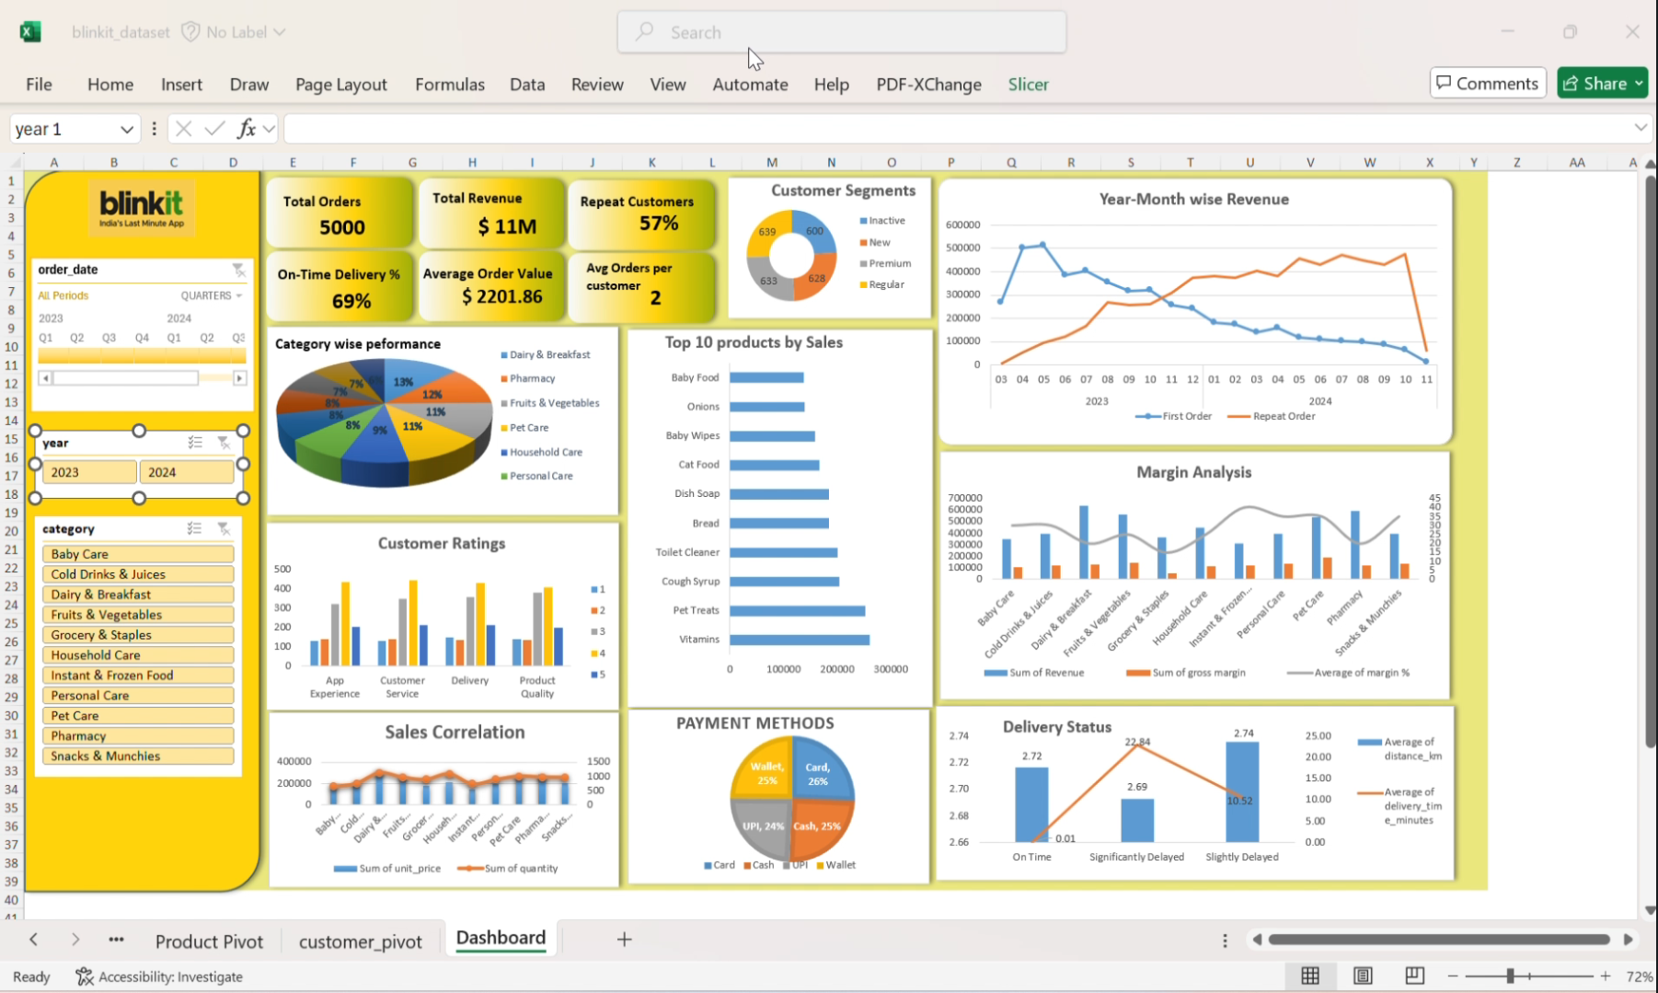

Category Wise Performance –Analysis
The Category Wise Performance chart shows a well-balanced distribution of sales across multiple product categories, with Dairy & Breakfast (13%) leading as the top contributor, followed closely by Pharmacy (12%) and Fruits & Vegetables (11%), indicating strong demand for daily essentials. Pet Care (11%) and Personal Care (9%) also contribute significantly, reflecting repeat-purchase behavior. Mid-tier categories like Snacks & Munchies, Cold Drinks & Juices, and Grocery & Staples each hold an 8% share, showing consistent consumption. Lower-performing segments such as Baby Care (7%) and Instant & Frozen Food (6%) still add value but offer growth potential. Overall, the chart highlights a healthy spread of customer demand across essential, lifestyle, and convenience categories.

Overall Customer Experience Summary
Customers are largely satisfied across all four aspects—App Experience, Customer Service, Delivery, and Product Quality—evidenced by the dominance of 4-star and 3-star ratings. App usability and customer service are the strongest areas, while delivery has slight variation that may reflect logistical challenges. Product quality remains consistently good, reinforcing trust and repeat purchases. Overall, the business provides a strong, reliable, and customer-friendly experience with opportunities for small refinements in delivery and product consistency.

Sales Correlation
The Sales Correlation chart compares the total unit price (revenue) and quantity sold across different product categories. Categories like Dairy & Breakfast and Fruits & Vegetables show both high quantity and high revenue, indicating strong demand and consistent sales. Pet Care and Pharmacy also generate high revenue despite moderate quantities, suggesting higher-priced items. In contrast, categories like Instant & Frozen Food and Baby Care have lower quantities and revenue, reflecting limited demand. Overall, the chart shows that essential categories drive the highest sales volumes, while premium or specialized categories contribute more through higher pricing.

Customer Segmentation
The Customer Segments chart shows a well-balanced distribution of users across four categories, indicating a diverse customer base. Regular customers (639) form the largest group, showing strong ongoing engagement. Premium customers (633) are also significant, highlighting a loyal and high-value segment. New customers (628) are nearly equal in number, reflecting steady customer acquisition. Meanwhile, Inactive customers (600) represent a smaller portion, suggesting relatively low churn. Overall, the business maintains a healthy mix of new, active, and high-value customers.

Top 10 Products by Sales
The Top 10 Products by Sales chart highlights the highest-earning items across categories. Vitamins lead with the highest sales, followed closely by Pet Treats and Cough Syrup, indicating strong demand for health and pet-related products. Mid-tier performers like Toilet Cleaner, Dish Soap, and Bread show steady household essentials driving consistent revenue. Lower in the top 10 list, products like Baby Food, Onions, and Baby Wipes still contribute significantly but generate comparatively lower sales. Overall, the chart shows a strong mix of essential, health, and pet-care items dominating the sales performance.

Payment Methods
The Payment Methods chart shows an almost even distribution of how customers prefer to pay for their orders. Card payments lead slightly at 26%, indicating they are the most commonly used option. Cash and Wallet payments each account for 25%, showing that both traditional and digital wallet methods are equally popular among users. UPI payments stand at 24%, making it another widely adopted method, especially for quick transactions. Overall, the chart highlights that customers use a diverse mix of payment options, with no single method overwhelmingly dominant.

Year-Month Wise Revenue for First and Repeat Order
The Year-Month Wise Revenue chart shows a clear contrast between revenue from first-time customers and repeat customers over time. First order revenue peaks early in 2023 and then steadily declines throughout 2023 and 2024, indicating fewer new customers joining or reduced initial spending. In contrast, repeat order revenue shows a strong upward trend, growing consistently through 2023 and stabilizing at higher levels in 2024. This suggests strong customer retention and loyalty, with existing customers driving most of the revenue. Toward the end of the timeline, both lines show a sharp drop, likely due to incomplete data for the last month. Overall, the chart highlights the business’s reliance on repeat customers for sustained revenue growth.

Margin Analysis
The Margin Analysis chart compares revenue, gross margin, and margin percentage across different product categories. Categories like Dairy & Breakfast, Pet Care, and Pharmacy generate high revenue, with Pet Care also showing one of the strongest margin percentages. Snacks & Munchies and Personal Care have relatively high margin percentages despite moderate revenue, indicating strong profitability. On the other hand, Grocery & Staples and Fruits & Vegetables show lower margin percentages, reflecting the typically low-margin nature of essential goods. Overall, the chart highlights that while some categories drive revenue, others contribute more to profit, creating a balanced business model.

Delivery Status
The Delivery Status chart compares the average delivery distance with the average delivery time across three delivery categories. On-time deliveries occur at an average distance of 2.72 km with almost no delay (0.01 minutes), indicating efficient service for nearby orders. Significantly delayed deliveries have a slightly shorter distance (2.69 km) but the highest delivery time of 22.84 minutes, suggesting operational or traffic-related issues rather than distance. Slightly delayed deliveries occur at the longest distance (2.74 km) with a moderate delay of 10.52 minutes, showing that distance contributes to minor delays. Overall, delays are influenced more by operational challenges than distance alone.

